**Multimodal Thinking: Comics, Infographics and Essential Skills**

**The Digital Cultures Lab at Douglas College**

**The Douglas College Maker Lab**

**Tuesday, 12 May 2015 from 6:30 PM to 9:00 PM (PDT)**

**Peter Wilkins and David Wright**

**Essential Skills:** The skills needed for work, learning and life. They provide the foundation for learning all other skills and enable people to evolve with their jobs and adapt to workplace change.

**Comics:** A sequence of drawings in boxes that tell an amusing story, typically printed in a newspaper or comic book.

**Infographics:** A visual image such as a chart or diagram used to represent information or data.

**This Session:** Aimed mainly at "outside-the-box" thinkers, tinkerers, doodlers, and those individuals who need to synthesize a large amount of information into a succinct form, this first workshop of the New Westminster Innovation Series will explore how essential skills collides with comics and infographics to allow for a"multimodal" forms of communication. Multimodal communication is the discussion of how information is conveyed through different media forms--comics, print, internet, pictures, infographics, television, film, etc. Hoping to attract emerging creative thinkers and entrepreneurs, this workshop will provide plenty of time for networking and open discussion while leading participants through some hands on multimodal experiences.

**Schedule:**

**6:45pm** (or so) find your place around the table

* Introductions, summary of activities
* What are Essential Skills and what questions arise out of drawing when we think about it as it is related to facets of essential skills?
* **TASK 1:** Think of an idea, and draw it (10 minutes)

**7:20pm**

* Summary, comment, discussion

**7:35pm**

* What should we consider about comics that might translate into helping us synthesize or deploy information? How might we think about conveying meaning?
* **TASK 2:** Draw the River Market (making choices about what you think is important to include and thinking about spatial relationships) (15 minutes)
* Summary, comment, discussion

**8:05pm**

* Space, divisions, and how to convey information
* **TASK 3:** add some words to your two first drawings (think about the choices you’re making again; why include the words you want to include, what are they doing?) (10 minutes)

**8:35pm**

* Summary, comment, discussion
* Concluding remarks
* **Next Event – Tuesday May 26th 6:30 – 9:00pm – 3D Printing and Scanning - Possibilities and Limitations**
* **Please leave us comments about the session**

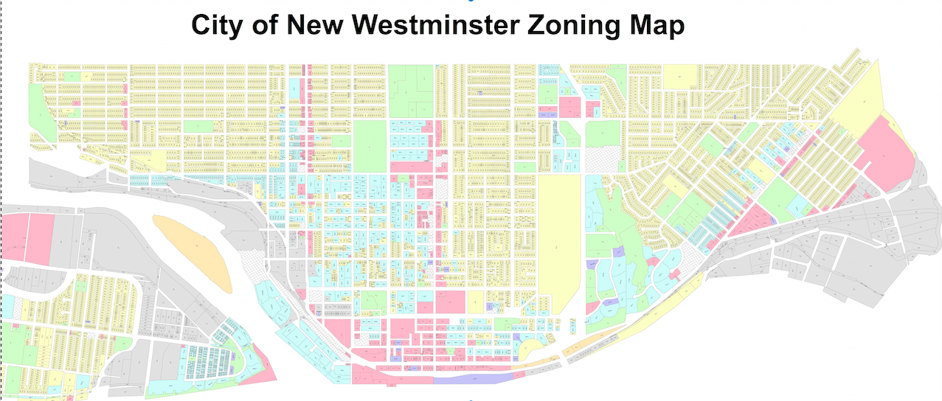

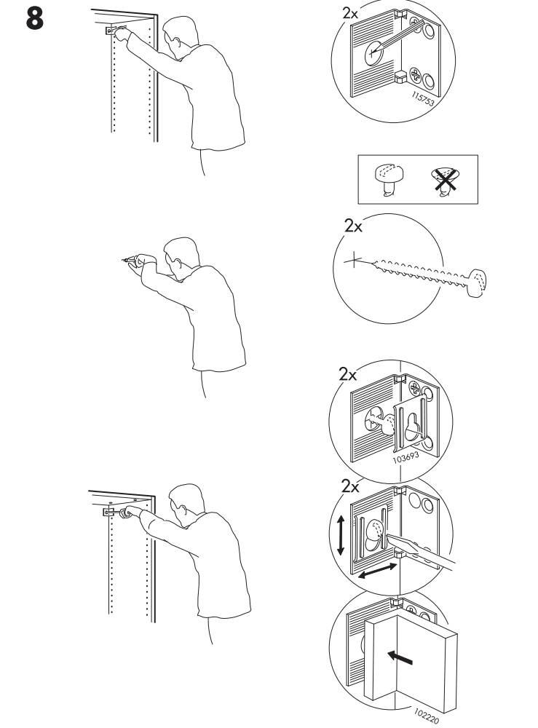

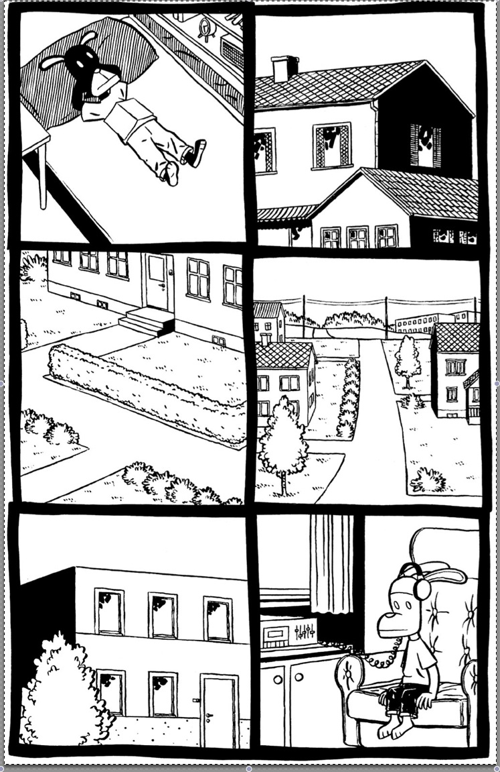

**Hey, Wait… (Jason)**

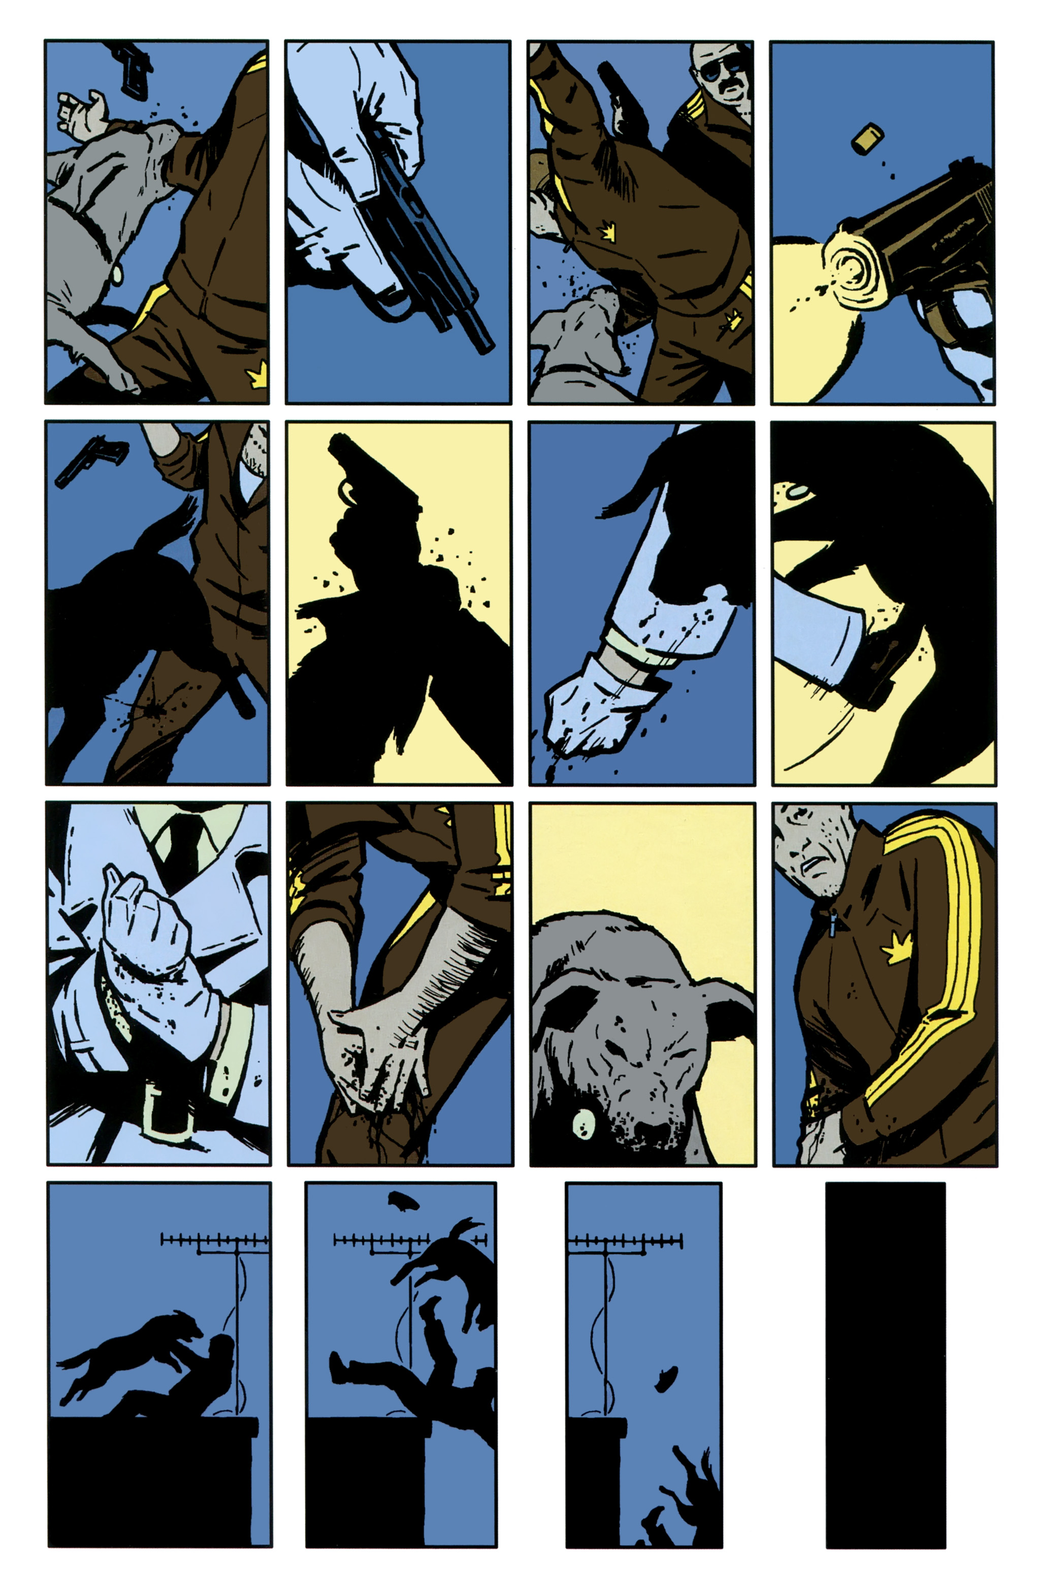

**Hawkeye #11 (Aja / Fraction)**

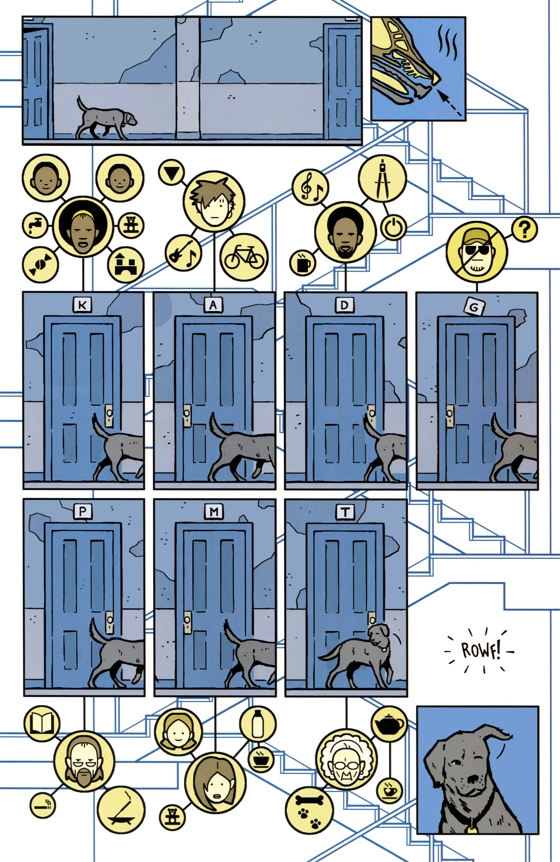

**Hawkeye #11 (Aja / Fraction)**

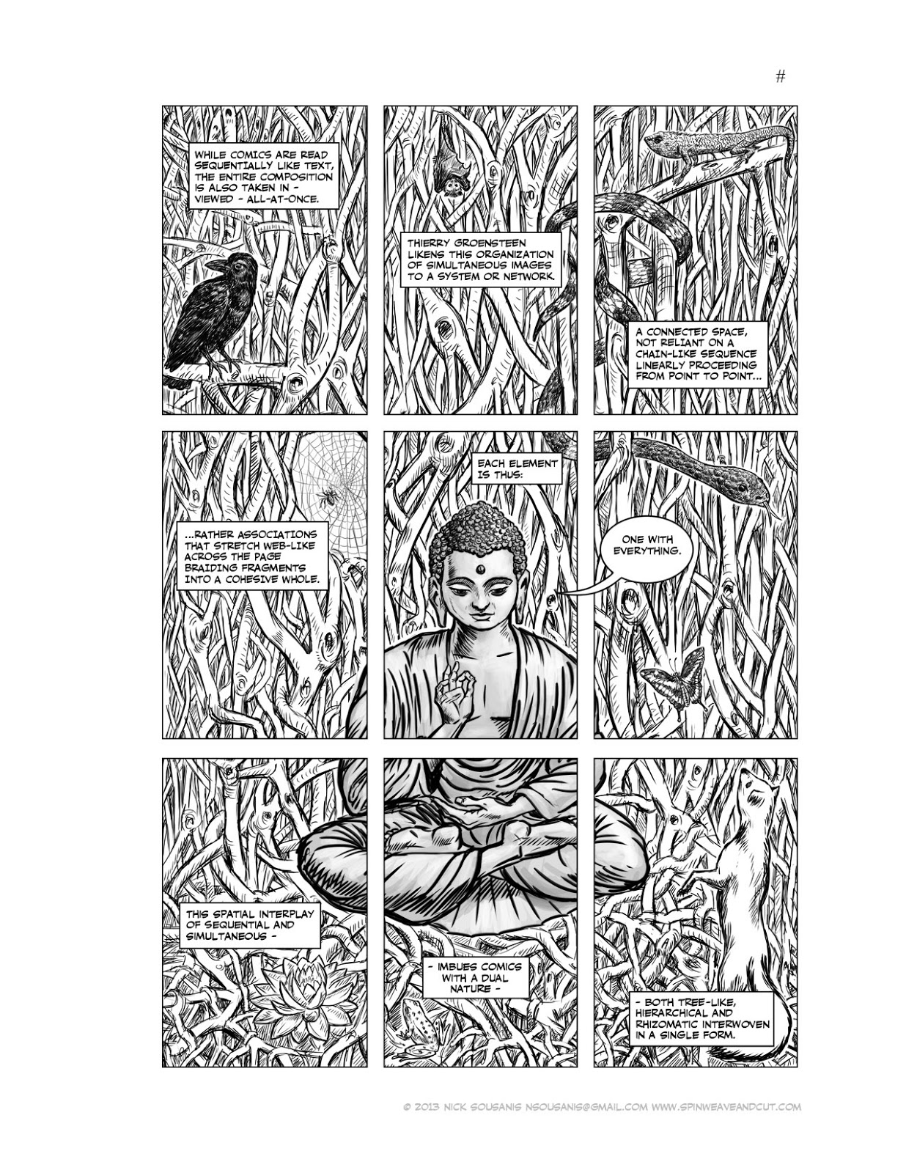

**Unflattening (Nick Sousanis)**

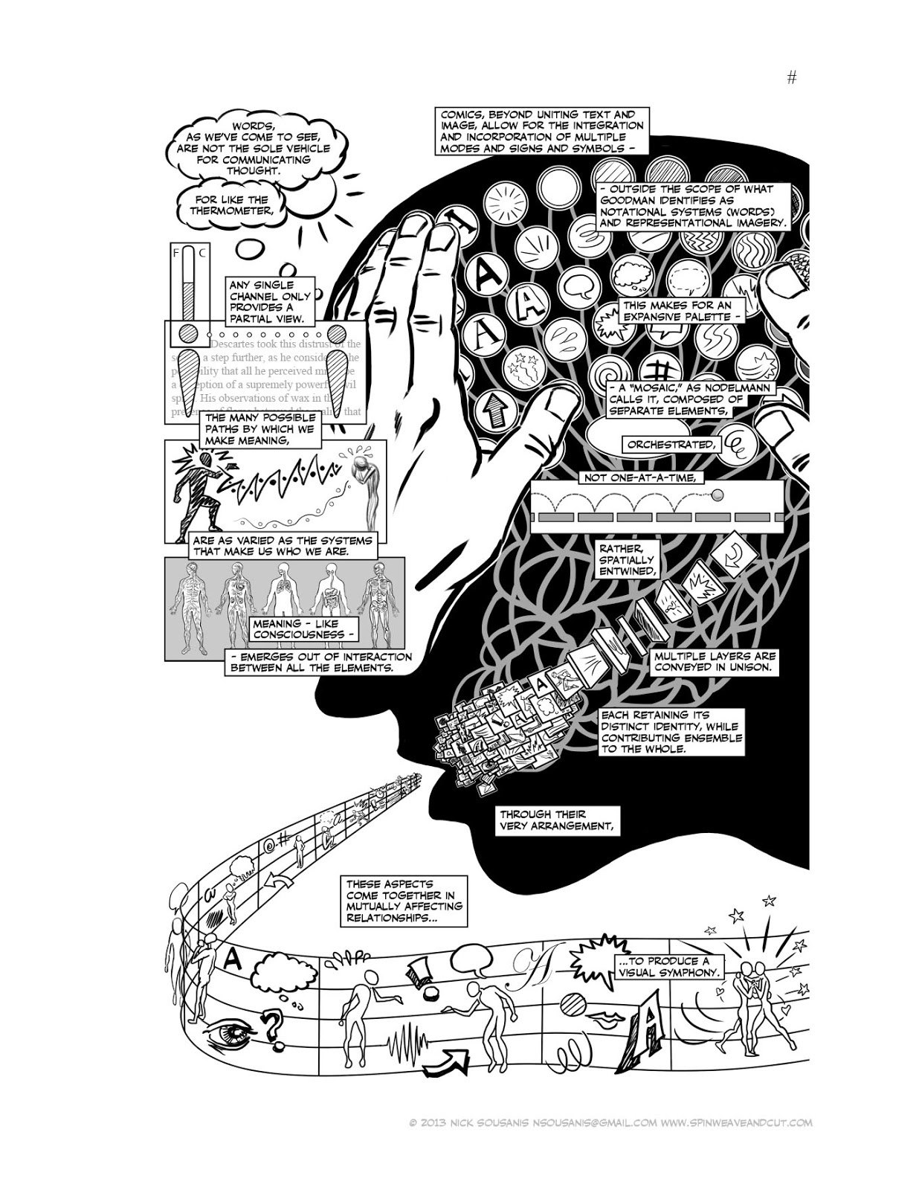

**Unflattening (Nick Sousanis)**

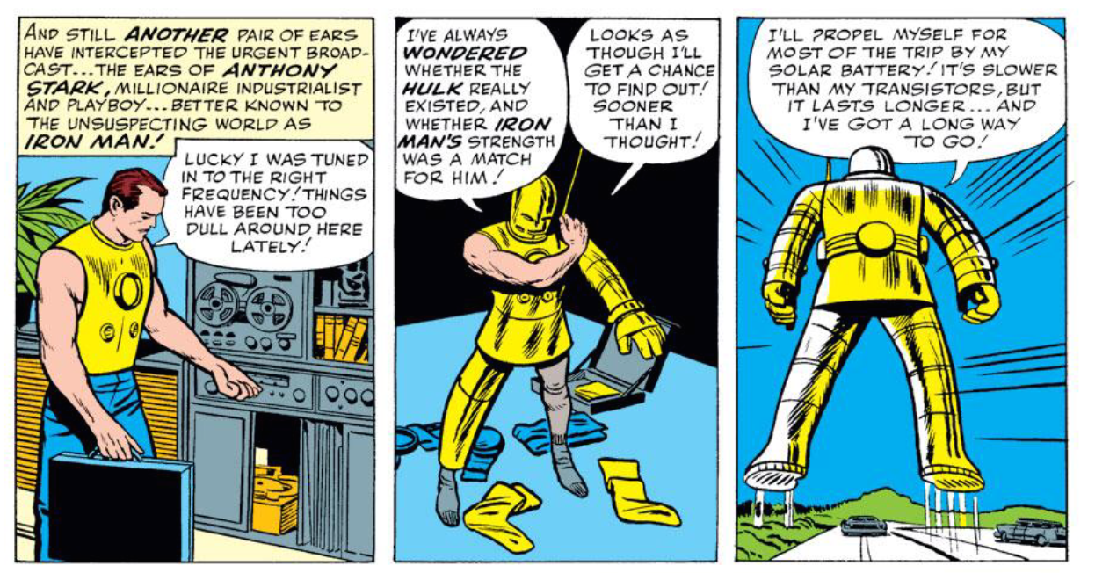

**Iron Man**

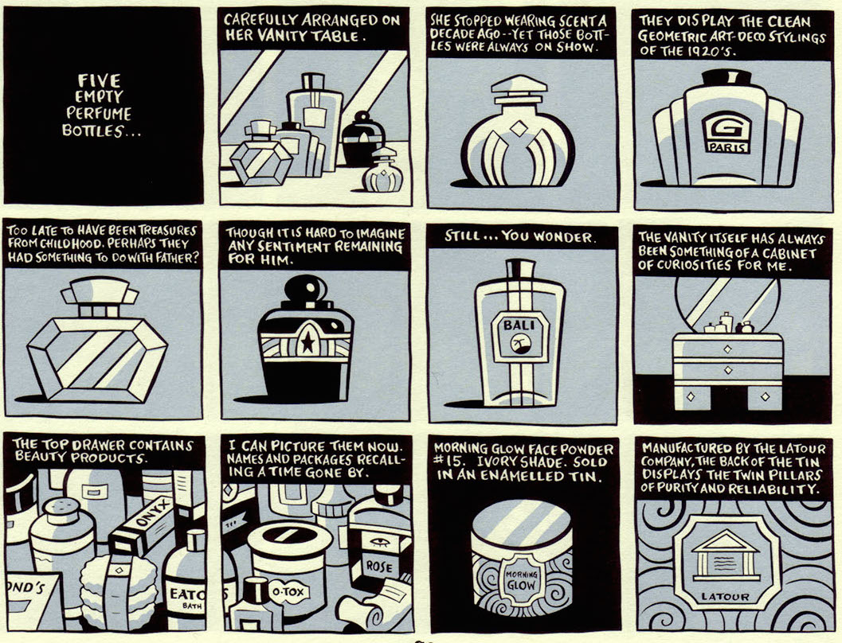

**It’s a Good Life If You Don’t Weaken (Seth)**